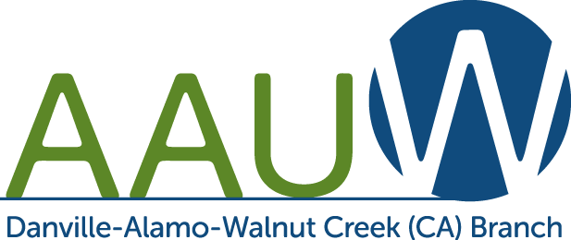

Danville-Alamo-Walnut Creek AAUW
COVID-19 Liability Release

I, the undersigned, agree to follow all masking, social distancing and vaccination requirements as directed by Contra Costa County and the Danville-Alamo-Walnut Creek (DAW) branch of the AAUW as a condition of admittance to this branch meeting or activity.
I, the undersigned, understand that there is risk involved with COVID-19 when attending any meetings or activities held in public or private venues, regardless of following all of the above protocols.
Knowing there is risk involved, I solely assume all risks related to exposure of COVID-19 and any effects related thereafter when attending a DAW AAUW meeting or activity.
I, the undersigned, agree to hold the DAW AAUW branch, its board members and its members harmless and release any liability, illness, losses or death related to exposure to COVID-19 from this meeting or activity.
I, the undersigned, have read and understand the above waiver and release, I understand the risks posed by potential exposure to COVID-19, and I sign this release voluntarily.

Date ______________________ Event ______________________

Attendee’s Name ________________________________________________________
(Print)

Attendee’s Name ________________________________________________________
(Signature)

Attendee’s Contact Information ____________________________________________
(email or phone number)

